CS 340 README

About the Project/Project Two: Grazioso Salvare Dashboard
This project is a web-based dashboard built using Python, Dash, and MongoDB. It allows users to interact with and visualize animal shelter data provided by Grazioso Salvare. The dashboard connects to a MongoDB database through a custom CRUD Python module and displays the data using an interactive data table, pie chart, and geolocation map.

Motivation
This project was created to demonstrate how backend systems interact with databases in a real-world scenario. It simulates how an animal shelter or clinic could store and access digital records for animals in an organized and efficient way. Learning how to store, retrieve, update, and remove data is a key skill in software development, and this project helps build that foundation.

Functionality
The dashboard includes the following features:
- Interactive filtering options (radio buttons)
- Dynamic data table displaying animal records
- Pie chart showing the top 10 breed distribution
- Geolocation map displaying animal locations
Users can filter the data using:
- Water Rescue
- Mountain or Wilderness Rescue
- Disaster or Individual Tracking
- Reset (all data)
Each filter updates all dashboard components in real time. The dashboard retrieves filtered data from MongoDB using query dictionaries passed through the CRUD module.

Screenshots
- Initial Dashboard (Reset)
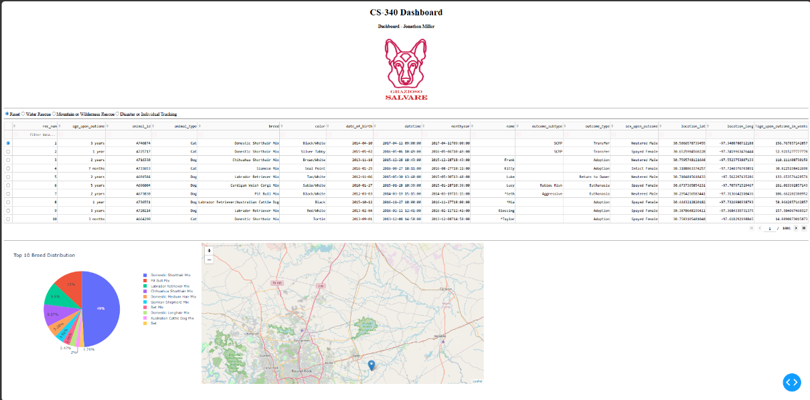

- Water Rescue Filter Applied
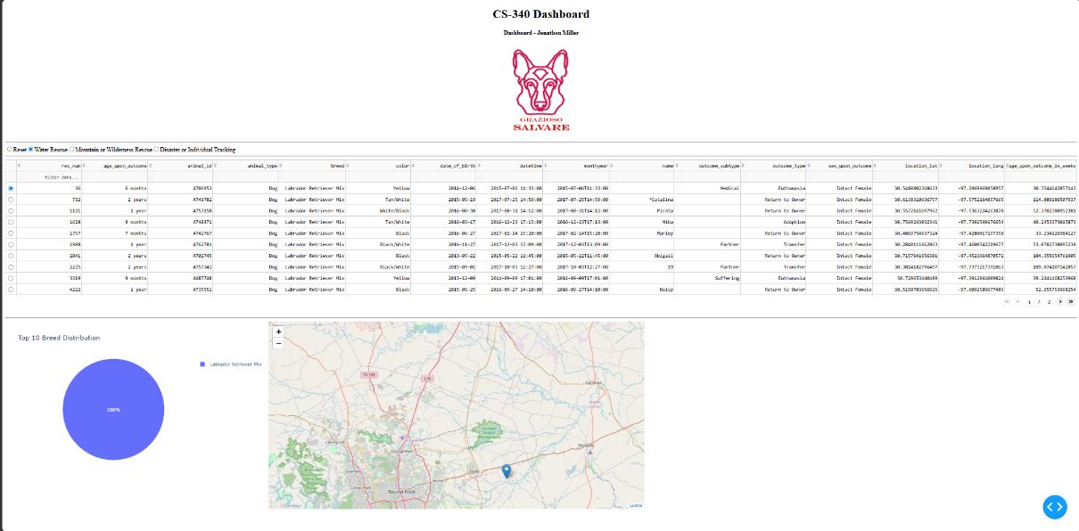
- Mountain/Wilderness Rescue Filter Applied
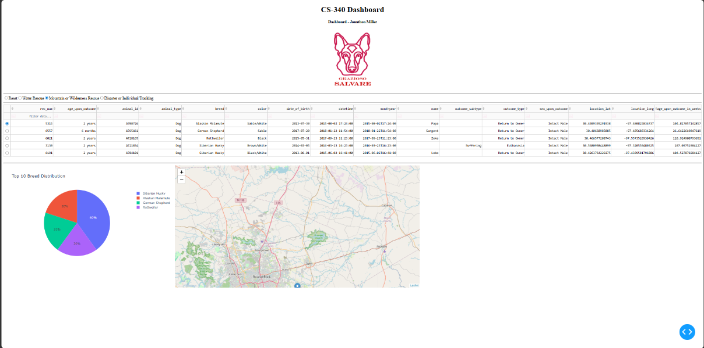
- Disaster/Tracking Filter Applied
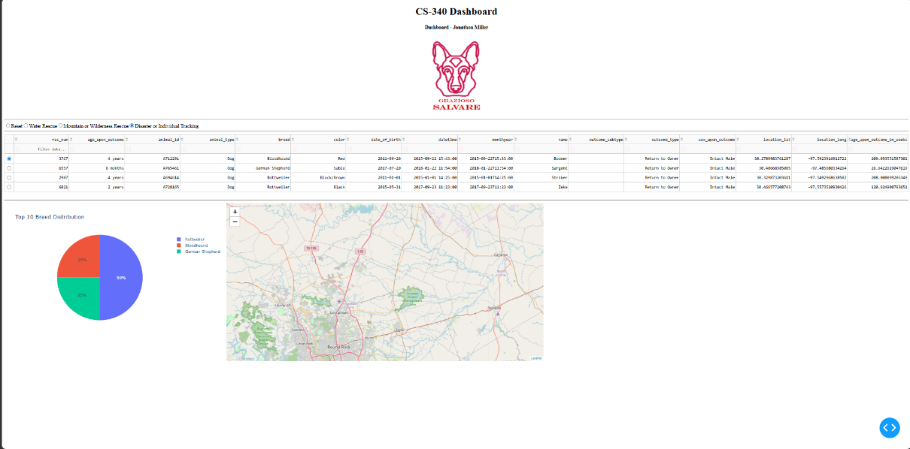

Tools Used
- Python – main programming language
- MongoDB – database for storing animal records
- PyMongo – connects Python to MongoDB
- Dash – web framework for dashboard UI
- Plotly Express – used for pie chart visualization
- Dash Leaflet – used for geolocation map
- Jupyter Notebook/Codio – development environment
MongoDB was chosen because it stores flexible JSON-like documents, which works well with animal shelter data. Dash was used because it allows building interactive dashboards directly in Python.

How to Run
- Start MongoDB
- Ensure database aac and collection animals exist
- Ensure user aacuser is created
- Open the ProjectTwoDashboard.ipynb file in Jupyter/Codio
- Run all the cells

Challenges
One challenge was handling large amounts of breed data in the pie chart, which caused clutter. This was resolved by limiting the chart to the top 10 breeds.
Another challenge was connecting the dashboard filters to MongoDB queries. This was solved by properly structuring queries and passing them through the CRUD module.

Conclusion
This project demonstrates how a full-stack application can connect a database to a user interface using Python. The dashboard provides an intuitive way for Grazioso Salvare to filter and analyze animal data efficiently.

Contact
Jonathon Miller

